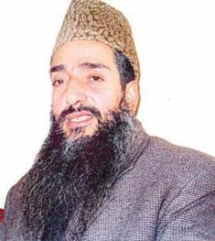**Maulana Shaukat Ahmed**

**About:** Maulana Shaukat Ahmed, the soft spoken 55-year-old chief of the Jamiat-e-Ahli-Hadees (JAH). The Maulana had been heading the JAH since 2004, when he was first elected President of the organization, followed by three more tenures in this responsible position. His last election came in 2010. The Jamiat-e-Ahli-Hadees grew under his leadership and had about 15 lakh followers and more than 800 mosques spread across the valley.

Maulana Shaukat Ahmed was a good man. In the coming years he would have played a significant role in the resolution of the Kashmir imbroglio. He had the vision, the stature and the capability to emerge as a leader of prominence.

**Murdered on :** 10 April 2011

**Attack details:** The killers simply wanted to spread mayhem and the Maulana became a target.

**Reason to him target:** Chief of the Jamiat-e-Ahli-Hadees (JAH), His unfortunate murder has been committed by someone who is an enemy of the people of Kashmir. It is most important to find out who the perpetrators were so that the real enemies stand exposed.

**Occupation:** The Maulana had been heading the JAH since 2004, when he was first elected President of the organization, followed by three more tenures in this responsible position.

**Belief:**  Maulana was a person who tread the righteousness path. It is possible that his liberalism and open thinking contributed to two earlier attempts on his life.

**Reaction of local population:** Maulana Shaukat Ahmed was a good man. In the coming years he would have played a significant role in the resolution of the Kashmir imbroglio. He had the vision, the stature and the capability to emerge as a leader of prominence.

**Link:** <https://in.news.yahoo.com/killed-maulana-shaukat-ahmed-why-20110410-004259-964.html>

